RETAIL SALES DATA PROCESSING AND BUSINESS INSIGHTS GENERATION
Prepared By:
Aparna P J
Project Title:
Retail Sales Data Engineering Pipeline and Business Intelligence Reporting
- Project Overview
This project was developed to process retail transaction data collected from multiple source systems and convert it into a clean, reliable, and reporting-ready dataset.
The provided retail datasets contained several data quality issues including missing prices, duplicate transactions, inconsistent product names, inconsistent category values, invalid quantities, varying date formats, and customer information that required masking.
The objective of the project was to build a complete data pipeline that performs data ingestion, cleaning, transformation, validation, KPI generation, and reporting through Power BI. The final output enables business users to analyze revenue performance, product sales, category trends, and regional sales performance using an interactive dashboard.
- Project Objectives
The main objectives of this project are:
• Ingest retail transaction data from multiple source files.
• Perform data profiling and validation.
• Identify and resolve data quality issues.
• Standardize product and category information.
• Remove duplicate transactions.
• Handle missing values.
• Clean invalid quantity records.
• Standardize transaction dates.
• Protect customer information through masking.
• Generate business KPIs.
• Create an interactive Power BI dashboard for business reporting.
- Technology Stack
Programming Language: Python
Development Environment: PyCharm
Libraries Used:
• Pandas
Data Source:
• Excel Files
Output Format:
• CSV Files
Reporting Tool:
• Power BI Desktop
Version Control:
• GitHub
- Dataset Description
The project consists of three datasets.
4.1 Product Details
This dataset contains master reference information for products.
Columns:
• product_id
• product_name
• category
• price
Total Records: 10
4.2 Retail Data 1
This dataset contains retail transaction records collected from one source system.
Total Records: 4243
Columns:
• transaction_id
• customer_id
• customer_name
• product_id
• price
• product_name
• category
• purchase_location
• city
• transaction_date
• quantity
• payment_method
• discount
• email
• phone
• payment_status
4.3 Retail Data 2
This dataset contains retail transaction records collected from another source system.
Total Records: 4251
Columns:
• transaction_id
• customer_id
• customer_name
• product_id
• price
• product_name
• category
• purchase_location
• city
• transaction_date
• quantity
• payment_method
• discount
• email
• phone
• payment_status

5. Architecture Diagram Description
The project architecture consists of three source Excel files containing product and retail transaction data. These datasets are processed using Python and the Pandas library. Data cleaning, validation, standardization, duplicate removal, missing value handling, date conversion, and PII masking are performed during the transformation stage. The cleaned dataset is exported as CSV files and loaded into Power BI for visualization and reporting. The final dashboard provides business insights through KPIs, charts, and interactive filters.

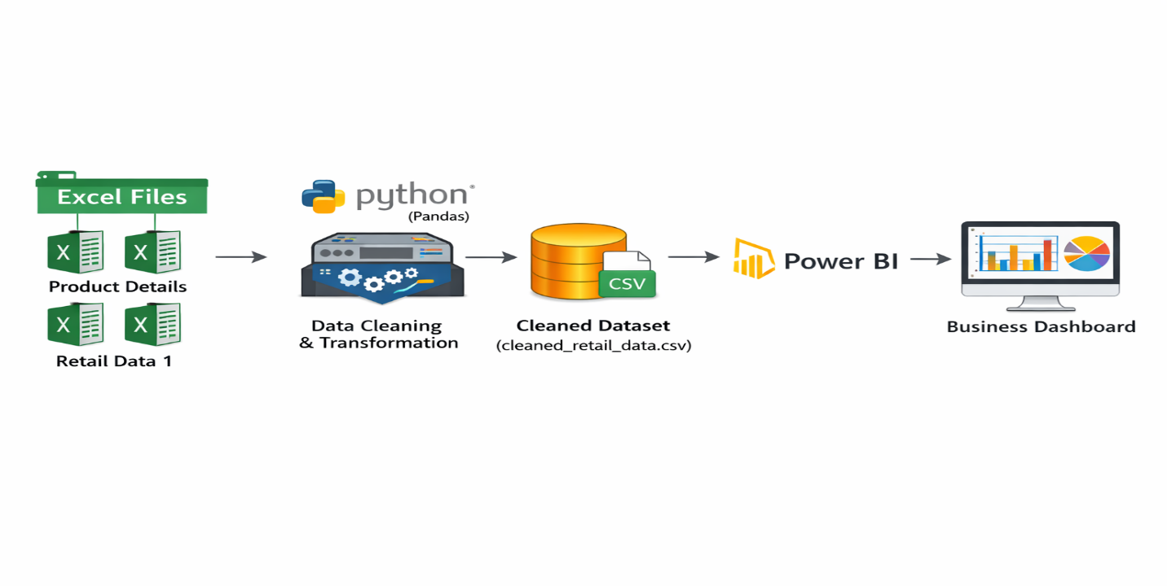

6. Data Flow Diagram
The data flow begins with the Product Details, Retail Data 1, and Retail Data 2 datasets. These datasets are ingested into the processing pipeline and subjected to profiling to identify missing values, duplicates, invalid quantities, inconsistent categories, and date format issues. After profiling, data cleaning and transformation activities are performed. Business KPIs are then generated from the cleaned data, and the resulting dataset is exported for Power BI reporting. Finally, dashboards are created to present business insights and performance metrics.

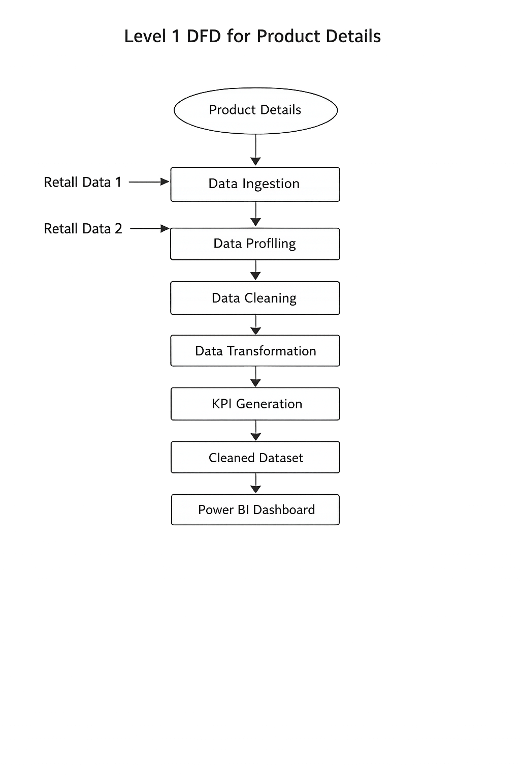

7. Data Profiling Findings
Before performing any data transformation, a detailed profiling exercise was conducted on all three datasets to understand their structure, quality, completeness, and consistency. The purpose of profiling was to identify potential data quality issues that could impact reporting accuracy and business analysis.
The product master dataset contained 10 records and was used as the reference source for validating product-related information. No missing values were identified in this dataset.
The two retail transaction datasets contained 4,243 and 4,251 records respectively. A review of the datasets revealed several data quality issues that required corrective action before analysis.
The most significant issue identified was missing price information. Retail Data 1 contained 404 records with missing prices, while Retail Data 2 contained 405 records with missing prices. Since revenue calculations depend directly on product pricing, these missing values needed to be resolved using the product reference dataset.
Product names were found to be inconsistent across the datasets. The same product appeared in multiple formats such as uppercase, lowercase, and title case representations. Examples included Laptop, LAPTOP, and laptop. Similar inconsistencies were observed for Phone, TV, Dining Table, Refrigerator, Mixer Grinder, and other products.
Category values also lacked standardization. Multiple representations of the same category were present, including Electronics, ELEC, and electronics. Similar inconsistencies were identified for Clothing, Furniture, and Home Appliances.
The transaction quantity field contained invalid values such as zero and negative quantities. These records do not represent valid sales transactions and therefore required further investigation and removal.
Duplicate transaction IDs were identified after combining the two retail datasets. Duplicate transactions can lead to double-counting of revenue and inaccurate reporting; therefore, these records required cleansing.
The transaction date field contained multiple date formats. Some records were stored as standard datetime values while others were stored using alternative formats. Standardization was required to ensure accurate time-based reporting.The datasets also contained personally identifiable customer information, including email addresses and phone numbers. To comply with data privacy requirements and good data governance practices, masking techniques were applied before the data was used for reporting and visualization.
The profiling phase provided a clear understanding of the quality issues present within the source data and helped define the transformation strategy implemented in the subsequent stages of the project.
8. Data Cleaning and Transformation
The data cleaning and transformation phase was designed to improve data quality, ensure consistency, and prepare the dataset for business intelligence reporting.
The first step involved merging Retail Data 1 and Retail Data 2 into a single consolidated transaction dataset. Combining both sources created a unified view of retail transactions and simplified downstream processing.
After merging, product names were standardized to eliminate variations in capitalization and naming conventions. All product names were transformed into a consistent format to ensure accurate grouping, filtering, and reporting. Standardized product names included Dining Table, Laptop, Microwave, Mixer Grinder, Phone, Refrigerator, Shirt, Shoes, Sofa, and TV.
Category values were then standardized using the product master dataset. Category abbreviations and inconsistent naming patterns were replaced with the official category values. The final standardized categories included Electronics, Furniture, Home Appliances, and Clothing.
Missing price values were resolved using the product reference dataset. Prices were mapped based on product_id, ensuring that all transactions contained valid product pricing information. This step was essential because revenue calculations depend directly on product price values.
The quantity field was validated to identify records containing invalid sales quantities. Transactions with quantity values less than or equal to zero were considered invalid and removed from the dataset. A total of 93 invalid records were eliminated during this process.
Duplicate transaction IDs were identified and removed to prevent double counting of sales and revenue. After duplicate removal, the dataset contained only unique and valid transactions.
The transaction date field was standardized by converting all values into a consistent datetime format. This ensured accurate aggregation and trend analysis within Power BI. Following standardization, no invalid dates remained in the dataset.
To protect sensitive customer information, masking techniques were applied to email addresses and phone numbers. Email addresses were partially masked while retaining domain information, and phone numbers were masked except for the final few digits. This approach preserved analytical usefulness while protecting customer privacy.
Finally, derived business fields were created to support reporting and analysis. Revenue calculations, monthly reporting attributes, and aggregation-ready fields were generated to facilitate KPI reporting and dashboard creation.
The outcome of the transformation process was a clean, validated, and analytics-ready dataset suitable for business intelligence reporting.
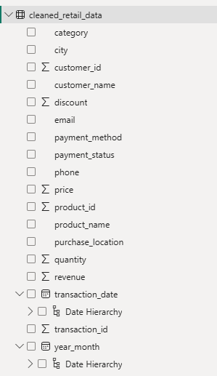
9. KPI Generation
Following data cleansing and transformation, a set of business KPIs was generated to support management reporting and performance analysis.
The primary KPI calculated was Total Revenue. Revenue was derived using transaction quantity, product price, and applicable discount information. This metric provides a consolidated view of business performance across all sales transactions.
Revenue by Category was calculated to evaluate the contribution of each product category to overall sales performance. This metric enables management to identify the strongest-performing categories and compare category-level profitability.
Revenue by City was generated to measure sales performance across different geographic locations. This KPI helps identify high-performing markets and supports regional business planning.
Top Selling Products were identified using aggregated sales quantities. This analysis highlights products with the highest customer demand and supports inventory and merchandising decisions.
Monthly Revenue Trend analysis was performed to understand revenue fluctuations over time. By aggregating revenue on a monthly basis, business users can identify growth patterns, seasonal variations, and sales trends.
Additional KPIs generated during the project include:
• Total Transactions
• Total Quantity Sold
• Unique Customers
• Revenue by Payment Method
These KPIs collectively provide a comprehensive view of operational performance and enable business users to make informed decisions based on reliable data.
10. Project Output
The final output of the project is a clean and reporting-ready retail sales dataset that can be directly consumed by business intelligence tools.
After completing all cleansing and validation activities, the final dataset contained 7,914 valid retail transactions. All identified quality issues including missing prices, duplicate transactions, invalid quantities, inconsistent naming conventions, and date format inconsistencies were successfully resolved.
The cleaned dataset was exported as cleaned_retail_data.csv and served as the primary source for Power BI reporting.
In addition to the master dataset, several aggregated output files were generated to support analytical reporting and validation activities. These included category-level revenue summaries, city-level revenue summaries, product performance summaries, and monthly revenue trend data.
The final output files generated during the project were:
• cleaned_retail_data.csv
• revenue_by_category.csv
• revenue_by_city.csv
• best_selling_products.csv
• monthly_revenue.csv
These files provide both detailed and summarized views of the data and can be used for future reporting, validation, and analytical purposes.
11. Power BI Dashboard
The Power BI dashboard was created using the cleaned dataset.
Dashboard Components:
KPI Cards
• Total Revenue
• Total Transactions
• Total Quantity Sold
• Unique Customers
Charts
• Revenue by Category
• Revenue by City
• Monthly Revenue Trend
• Top Selling Products
• Revenue by Payment Method
Interactive Filters
• Category
• City
• Payment Method
11.1 Dashboard Screenshots

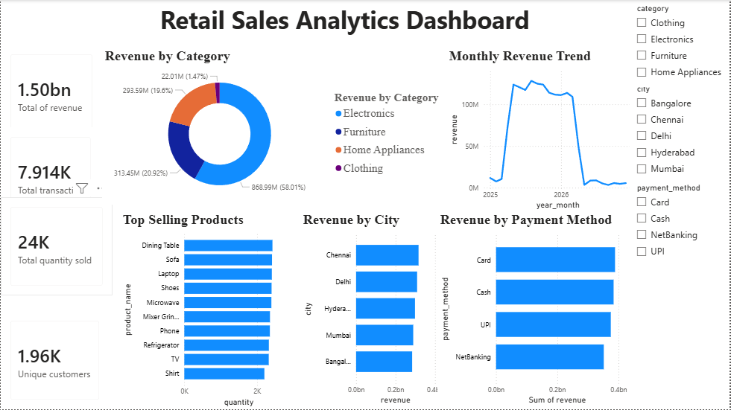

12. Business Insights
The analysis of the cleaned retail dataset provided several meaningful business insights.
Category-level analysis revealed that Electronics generated the highest revenue contribution among all product categories. This indicates strong customer demand for electronic products and highlights Electronics as a key revenue-driving segment of the business.
Furniture also contributed significantly to overall revenue, supported by strong sales of products such as Dining Table and Sofa. Home Appliances represented another important revenue contributor within the retail portfolio.
Clothing generated comparatively lower revenue than the other categories. While sales activity exists within this category, its overall contribution to total revenue remains relatively small compared to Electronics, Furniture, and Home Appliances.
Regional analysis showed that revenue was distributed across Bangalore, Chennai, Delhi, Hyderabad, and Mumbai. Among these locations, Chennai generated the highest revenue contribution, indicating strong sales performance within that market.
Product-level analysis identified TV, Dining Table, Laptop, Sofa, and Microwave among the strongest-performing products based on sales quantity. These products consistently contributed to transaction volume and overall revenue generation.
Monthly revenue trend analysis demonstrated variations in sales performance across different months. The trend visualization provides management with the ability to monitor revenue patterns and identify periods of stronger or weaker sales activity.
Customer analysis showed that the final cleaned dataset contained approximately 1.96K unique customers, indicating a broad customer base across multiple locations and product categories.
Payment method analysis highlighted the use of multiple payment channels including Cash, Card, UPI, and NetBanking. The availability of multiple payment options reflects diverse customer payment preferences and supports transaction convenience.
Overall, the generated insights provide a clear understanding of category performance, product demand, regional sales distribution, customer activity, and revenue trends, enabling more effective business decision-making.
13. Assumptions
• Product master data contains correct pricing information.
• Product IDs uniquely identify products.
• Records with non-positive quantities are invalid transactions.
• Duplicate transaction IDs represent duplicate transactions.
• Standardized product names and categories are considered the correct business values.
14. Challenges Faced
• Handling missing prices.
• Standardizing inconsistent product names.
• Standardizing category values.
• Removing duplicate transactions.
• Processing multiple date formats.
• Protecting customer information through masking.
15. Conclusion
This project successfully converted raw retail transaction data into a structured, clean, and analytics-ready dataset suitable for reporting and business analysis. Throughout the project, multiple data quality issues such as missing prices, duplicate transactions, inconsistent product names, inconsistent category values, invalid quantities, and varying date formats were identified and resolved using systematic data cleaning and transformation techniques.
The data processing pipeline ensured that all records were standardized, validated, and enriched using the product master dataset. Sensitive customer information, including email addresses and phone numbers, was protected through masking techniques to maintain data privacy while preserving analytical usefulness.
After the cleansing process, a reliable dataset containing 7,914 valid transactions was generated and used for business intelligence reporting. Various KPIs such as Total Revenue, Revenue by Category, Revenue by City, Monthly Revenue Trend, Top Selling Products, Total Transactions, Total Quantity Sold, Unique Customers, and Revenue by Payment Method were calculated to support business analysis.
The final Power BI dashboard provides a consolidated view of sales performance across products, categories, cities, and payment methods. The generated insights help understand revenue distribution, customer purchasing patterns, product demand, and regional performance. Overall, the project demonstrates the complete workflow of data ingestion, data quality assessment, data transformation, KPI generation, and dashboard development, resulting in a reporting solution that supports informed business decision-making.

